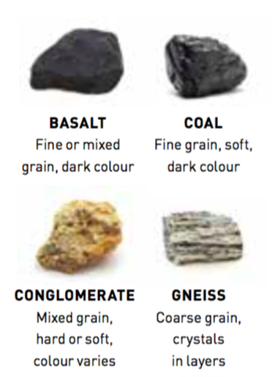Geology

Why Geology? Worksheet

Check your learning

1. Use the table below and the pictures and descriptions on the right to name the following rocks.
   1. I am light in colour with a fine grain. I am considered soft.
   2. I am light in colour with holes in the surface.
   3. I am soft, shiny and dark in colour. I am often used for flooring.
   4. I have mixed grains and my colour can vary.
2. 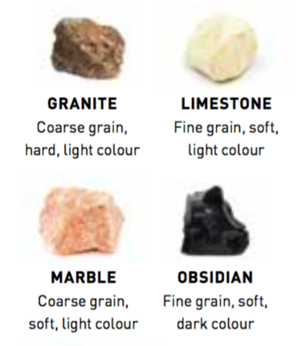What properties are used to identify different types of rocks?
3. Name two different uses for different types of rocks.
4. Why must properties other than colour be used to identify a rock?
5. 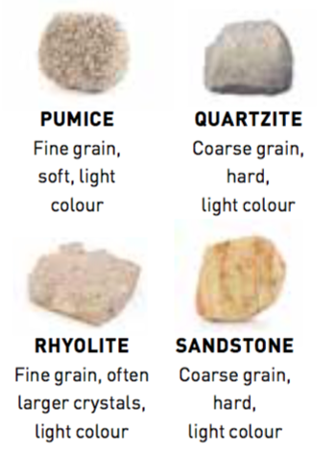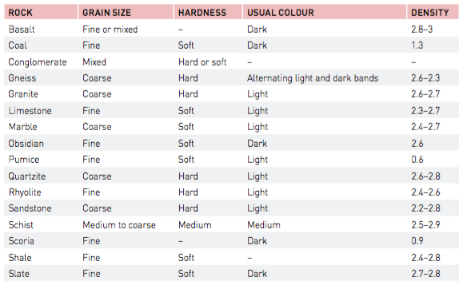What branch of science is the study of rocks?

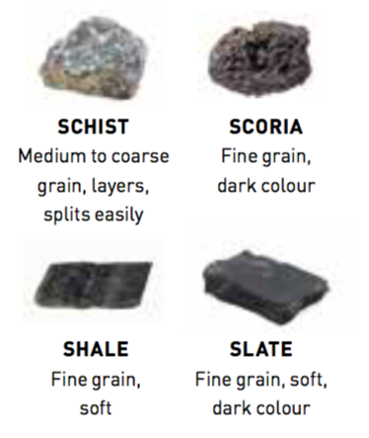Apply and analyse

1. Pumice has a density of 0.6. Water has a density of 1. Would you expect the pumice stone to float or sink? Explain your reasoning.

Extend your understanding

1. Who am I? Use table and pictures on the previous page to name the following rocks.
   1. I am dark in colour, am soft and have a fine grain size. Some say I look like black glass.
   2. I have course grain, am soft and light in colour. Sometimes I look pink and other times I look white.
   3. I am fine grained, have larger crystals and am light in colour. I am also very hard, with approximately one and a half times the density of water.

1. Research to determine which rocks you would select for the following purposes.
   1. Bench top
   2. Production of energy
   3. The removal of dead skin
   4. Roof tiles
   5. to produce cement

**How geology affects our lives**

Geology is all around us, from the sand and rock used to build the walls and roads, to the numerous minerals found in everyday life objects and in the food we eat, to the landscape around us and our leisure pursuits​. ​

Complete the following sentences using the words provided

**Energy** (decay, millions, fossil fuels)

The majority of the electricity we use in our homes comes from ______ ____. Fossil fuels such as coal, oil and gas are formed by the _____ of living organisms from _______ of years ago

**Food and Drink** (minerals, affect, soil, subsoil)

The food and drink we eat depends on the ____ it grows in. Soil can contain many different minerals that can ______ how our food grows. The ________ present in the soil are the result of how the soil and _______ formed.

**Fluoride in your toothpaste** (toothpaste, cavities, mineral)

Fluoride is a naturally occurring _______ that is added to __________ to help protect your teeth from ________.

**Calcium for your bones and teeth** (bodies, calcium, grass, calcium, dairy)

We know that _______ is necessary for healthy bones and teeth and we know milk and _____ products are good sources of it but where does it come from? Calcium is a mineral that can be found in the soil and this means grass contains lots of calcium too. When cows eat the _____ the calcium builds up in their ______ and comes out in their milk.

**Minerals in our smartphones and laptops** (Cobalt, minerals, laptops)

Our smartphones and _______ rely heavily on ________ such as Lithium, ______ and Gold.

**Water** (wells, beneath, rivers or lakes, shower, below)

The water we drink, the water we use to _______ and the water we use to flush our toilets can come from sources above or _____ ground. Above ground we can use water from _____ __ _____ that we can easily see but we can also find water _______ the ground. Water can sink through cracks and holes into rocks, here the water is stored in rock layers known as aquifers. This water can be reached using _____.